INDUCTION COOKER SYSTEM – LAYER-BY-LAYER BLOCK DIAGRAM
This diagram describes the physical, electrical, sensing, control, and communication layers of the induction cooker from top (cookware) to bottom (power input), showing how energy, signals, and feedback flow through the system.

1. COOKWARE & HEATING INTERACTION LAYER (TOPMOST)
Cookware (Pot / Pan)
- Ferromagnetic base (cast iron, steel, induction-compatible stainless steel)
- Eddy currents induced by an alternating magnetic field
- Direct heat generation inside the cookware material
Primary Phenomena
- Eddy current losses (I²R heating)
- Magnetic hysteresis losses
- Cookware temperature rise

2. OPTICAL & THERMAL SENSING LAYER (BELOW COOKWARE)
IR Temperature Sensor (MLX90614)
- Mounted below the glass, facing upward
- Measures cookware bottom surface temperature (non-contact)
- Provides real-time thermal feedback to the MCU
Functions
- Closed-loop temperature control
- Preset mode regulation (boil, fry, warm, etc.)
- Over-temperature protection (>300 °C emergency stop)

3. MECHANICAL ISOLATION & USER INTERFACE LAYER
Glass Cooktop (Ceramic / Tempered Glass)
- Electrically insulating
- Thermally resistant
- Mechanically supports cookware
- Transparent to IR radiation
User-Safety Role
- Electrical isolation between the user and power electronics
- Residual heat indication logic tied to temperature sensors

4. ELECTROMAGNETIC ENERGY TRANSFER LAYER
Work Coil (Induction Coil)
- High-current Litz wire
- Generates high-frequency alternating magnetic field (20–40 kHz)
Magnetic Field Coupling
- Field penetrates glass and cookware base
- Strength depends on coil current, frequency, and pot size

5. RESONANT POWER STAGE LAYER
Resonant Tank (L + C)
- Induction coil (L)
- Resonant capacitors (C)
- Tuned close to resonant frequency
Functions
- Maximizes power transfer efficiency
- Minimizes reactive current at resonance
- Enables phase-based cookware detection
Measured Signals
- Tank voltage (via voltage divider)
- Phase relationship with current

6. POWER CONVERSION & SWITCHING LAYER
Full-Bridge Inverter
- 4 × IRFP4110 MOSFETs
- Converts DC bus power into high-frequency AC
Gate Driver Stage
- IRS21867 / IRS21876 (×2)
- High-side & low-side drive
- Dead-time control and level shifting
Protection Role
- Fast shutdown on overcurrent, undervoltage, or fault

7. POWER MEASUREMENT & FEEDBACK LAYER
Current Sensing
- Shunt resistor or Hall-effect sensor
- Measures inverter output/coil current
Voltage Sensing
- Resonant tank voltage divider
- DC bus voltage divider (48 V input)
Derived MCU Information
- Real power vs reactive power
- Resonance condition (phase ≈ 0°)
- Cookware size, material, and presence
- Overcurrent / short-circuit detection

8. THERMAL MONITORING LAYER (ELECTRONICS)
Heatsink Temperature Sensor
- NTC thermistor or digital sensor
- Mounted on MOSFET heatsink
Coil Temperature Sensor
- NTC near induction coil
- Protects glass and PCB
Functions
- Thermal derating
- Automatic shutdown on overheat

9. CONTROL & INTELLIGENCE LAYER (CORE LOGIC)
Main MCU
Inputs
- Coil current
- Tank voltage
- DC bus voltage
- Phase angle (V–I)
- IR cookware temperature
- Coil temperature
- Heatsink temperature
- User commands (touch/app)
Processing Tasks
- Frequency tuning (20–40 kHz)
- Power modulation (PWM / frequency shift)
- Closed-loop temperature control
- Cookware detection (placement, size, type)
- Safety monitoring and fault handling
Outputs
- Gate driver control signals
- LCD/UI updates
- WiFi data packets

10. USER INTERFACE LAYER
Local Interface
- LCD display
- Capacitive touch buttons
- Temperature slider
Displayed Information
- Current temperature
- Mode (boil, fry, warm, etc.)
- Timer
- Fault messages

11. COMMUNICATION & CONNECTIVITY LAYER
WiFi Module (ESP32)
- MQTT or HTTP REST
- OTA firmware updates
Remote Interfaces
- Web application
- Mobile application
Capabilities
- Remote power control
- Temperature monitoring
- Preset selection
- Scheduling and notifications

12. POWER INPUT & PROTECTION LAYER (BOTTOMMOST)
DC Power Source
- 48 V Battery input
- Up to 40 A (≈1920 W)
Protection & Conditioning
- Fuse
- Transient suppressor (TVS)
- EMI filter
- Input filter
DC Bus
- Bulk capacitors
- Stable energy reservoir for inverter

13. OVERALL TOP-TO-BOTTOM FLOW SUMMARY
Cookware
↓
IR Temperature Sensing
↓
Glass Cooktop
↓
Magnetic Field
↓
Work Coil
↓
Resonant Tank (L+C)
↓
Full-Bridge Inverter
↓
Gate Drivers
↓
MCU Control & Feedback Processing
↓
DC Bus Capacitors
↓
EMI / Protection Network
↓
48 V DC Power Source
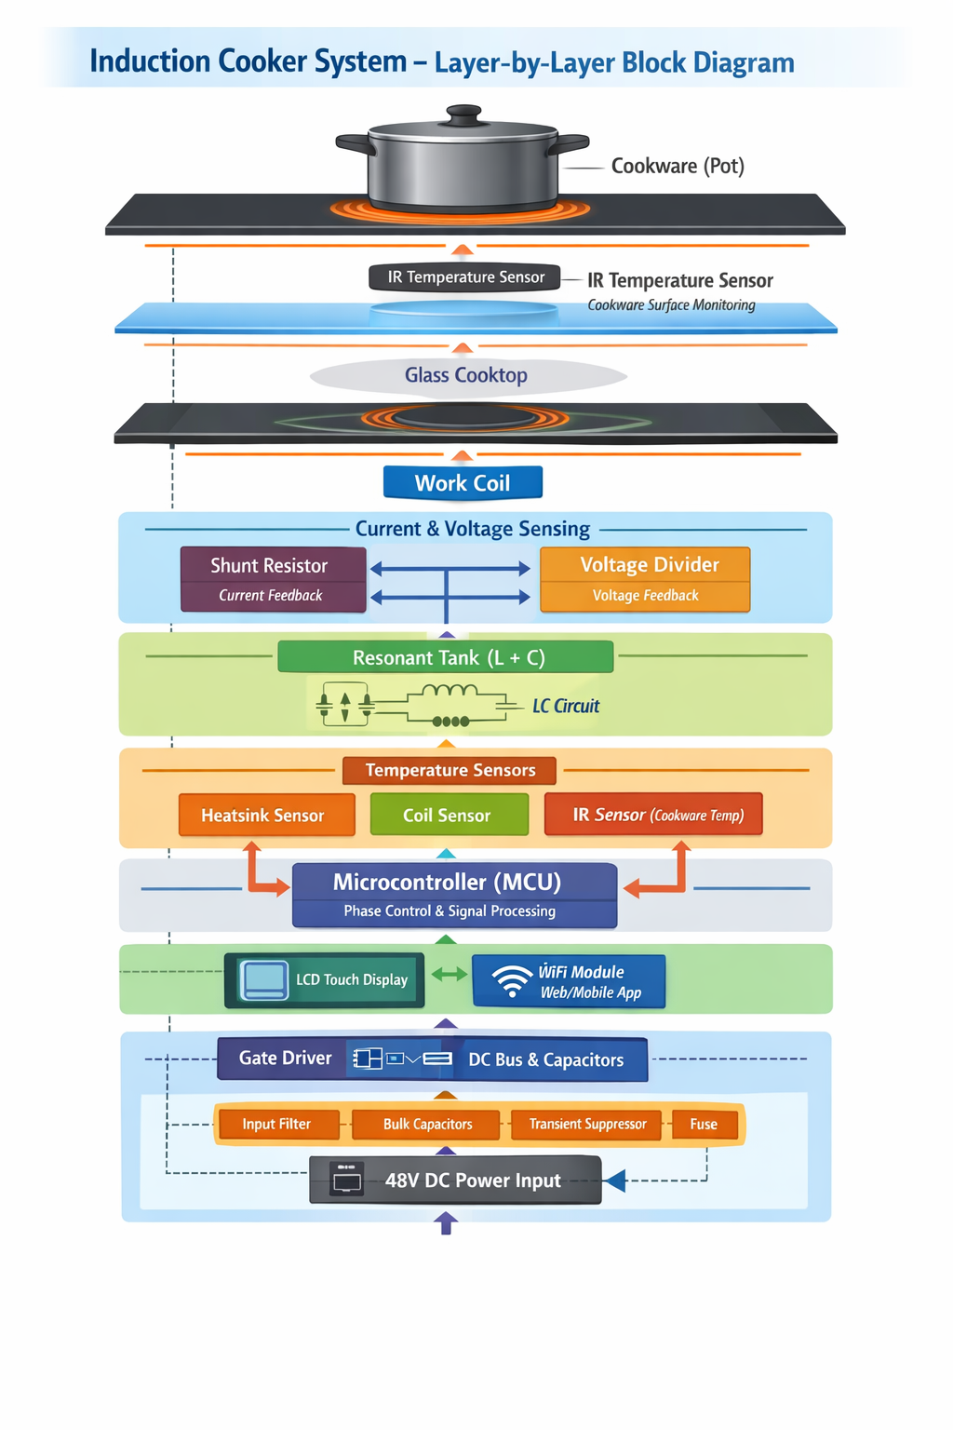oo

